DCSF defines the group supported by the National Programme for gifted and talented education as:

“Children and young people with one or more abilities developed to a level significantly ahead of their year group (or with the potential to develop those abilities).”

Since relative ability changes over time, learners should move on and off the register when appropriate, though such movement might be expected to reduce with age.

Principally that there is no single perfect instrument for identification – institutions are advised to use a ‘best fit’ model that draws on a range of evidence including qualitative and quantitative elements; argues that identification and provision are inseparable, because identification includes spotting potential through participation in learning opportunities; and envisages a continuous cyclical process of identification and review rather than a one-off process.

The following characteristics (taken from the 1998 Ofsted review of research by Joan Freeman) are not necessarily proof of high ability but they may alert teachers to the need to enquire further into an individual’s learning patterns and ability levels. He or she may: l be a good reader; l be very articulate or verbally fluent for their age; l give quick verbal responses (which can appear cheeky); l have a wide general knowledge; l learn quickly; l be interested in topics which one might associate with an older child; l communicate well with adults – often better than with their peer group; l have a range of interests, some of which are almost obsessions; l show unusual and original responses to problem-solving activities; l prefer verbal to written activities; l be logical; l be self-taught in his/her own interest areas; l have an ability to work things out in his/her head very quickly; l have a good memory that s/he can access easily; l be artistic; l be musical; l excel at sport; l have strong views and opinions; l have a lively and original imagination/sense of humour; l be very sensitive and aware; l focus on his/her own interests rather than on what is being taught; l be socially adept; l appear arrogant or socially inept; l be easily bored by what they perceive as routine tasks; l show a strong sense of leadership; and/or l not necessarily appear to be well-behaved or well-liked by others.

Underachievement
Gifted and talented underachievers may tend to: have low self-esteem; be confused about their development and about why they are behaving as they are; manipulate their environment to make themselves feel better; tend towards a superior attitude to those around them; and find inadequacy in others, in things, in systems, to excuse their own behaviours. Sometimes those with abilities in one or more areas of learning may also suffer from a disability or difficulty in others. This can present a considerable barrier to the achievement of potential, as well as leading to frustration and disaffection.

A range of popular methods for identification are listed below:

- Teacher/staff nomination
- Checklists
- Testing- achievement, potential and curriculum ability
- Assessment of children's work
- Peer nomination
- Parental information
- Discussions with children/young people
- Using community resources

Care should be taken to ensure that identification reflects ability, rather than just achievement; includes talent areas; and does not unduly disadvantage any group of learners, including those from lower socio-economic backgrounds, children in care, children with special educational needs and particular ethnic or gender groups.

Indicators of gifts and talents related to phase
Some children display signs of high ability at an early age. However, since an individual’s level of ability is not fixed and may develop significantly over time, the stage at which high potential is demonstrated will vary from one child to another. Teacher observation and informal assessment play an essential part in recognising high potential, particularly in the case of very young children. Whilst characteristics of high ability may be displayed at any age, some features may become particularly prominent during one phase of development and of schooling. Similarly, it is important that schools and colleges should meet the needs of gifted and talented learners in ways which are most appropriate for the stage of personal, social and emotional development which has been reached. The table below provides some examples of particular characteristics and needs of learners which may be most prominent, though not found exclusively, during one phase of schooling or another. These are indicative and not definitive.

Early Years | Primary School | Secondary School
Is it precocity or giftedness? | Needs fewer steps in process. | Questions rules/authority.
Uneven development. | Enjoys increased pace. | Non-conformity.
Gets cross if task is too easy/hard. | Needs less instruction and practice. | High ability/low motivation.
Needs to own extended tasks. | Thrives on independent study. | Keen sense of justice.
May display ‘unique creativity’. | Copes with abstract tasks. | Divergent thinking/creativity.
Often easily bored and disruptive. | Likes open-ended situations. | Excellent sense of humour.
Very good verbal reasoning. | Needs to learn to fail. | Growing self-determination.
Needs enrichment more than acceleration. | Responds to a wide variety of creative opportunities. | May develop lifelong passion for field or hobby.
Can show reflection above age. | Needs to be encouraged to take risks. | Intellectual curiosity stands outs.
Emotional literacy can lag behind academic work. | Needs to develop self-esteem in supportive environment. | Exceptional powers of concentration, stamina.
Identification for understanding and provision not labelling. | Whatever the intellectual level must remember actual age. | Needs to work with learners of similar ability in/out of school.

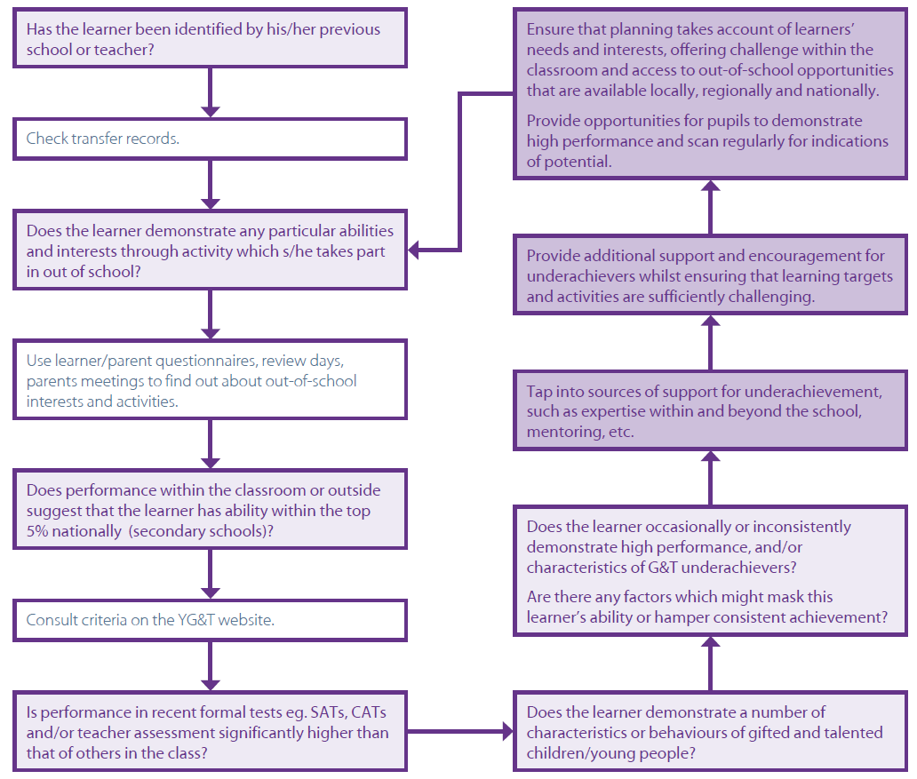

Definitions
Genius: An exceptional intelligence, creative power or other natural ability that could be internationally recognised.
Exceptionally Able: An intelligence or creative power or other natural ability that could be nationally recognised.
Gifted: Children who have advanced abilities in one or more academic subjects, such as maths and English.
Talented: Children who have advanced practical skills in areas such as sport, music, design or creative arts.
High Learning Potential (HLP) pupil: A child who is, or has the potential to be, considered Gifted or Talented.

Characteristics of the HLP child
HLP children stand out because they exhibit a blend of high ability, creativity, commitment and the potential to improve further. Children with HLP will typically exhibit many (though not necessarily all) of the following characteristics:

- Able to learn quickly
- A rich vocabulary
- Excellent memory
- A long attention span
- Able, and typically avid, readers
- Perseverance with difficult tasks
- A range of interests
- Are good at puzzles and problem solving
- Can talk through their reasoning
- Can connect well with others through empathy, leadership, teamwork and compassion
- Strong curiosity
- Energetic nature
- The desire to question things, including authority
- Creativity
- Imagination
- Observation skills
- Flexible thinking
- Great potential to develop further

Responsibilities of class teachers and support staff
- have a high degree of subject knowledge
- use outside agencies and advance curriculum materials where appropriate
- understand how to plan class work and homework in order to increase pace, breadth or depth
- use tasks and Assessment for Learning techniques that help pupils to develop perseverance and independence in learning
- use stimulating resources to scaffold learning experiences
- use ICT to extend and enhance pupil’s work
- use higher-order questioning and investigative activities to further develop thinking skills
- facilitate opportunities to participate in activities outside school
- provide opportunities to develop problem solving, leadership, teamwork and communication skills

Social and emotional considerations
We recognise that there is the potential for social stigmatisation to occur around the label of HLP, and that, under certain undesirable circumstances, children could be the targets of negative attention as a result of being registered as a HLP. Therefore, through encouragement of positive attitudes to learning, including SEAL/PSHE teaching, AFL techniques, reward schemes, and peer-working, we aim to ensure that HLP children are viewed by others as aspirational role-models.

